NEW FEATURES AND KNOWN ISSUES IN PIPELINE 5.1

Introduction
PipeLine 5.1 is an updated version of PipeLine 5.0 that includes several important new features and fixes bugs found in PipeLine 5.0 after its release in May 2010. This document updates “PipeLine 5.0: An Addendum to the PipeLine 4.0 User’s Guide.” It describes:
- new features included in PipeLine 5.1
- continuing known issues in PipeLine 5.1

New Features in PipeLine 5.1

Language Features
PipeLine 5.1 now includes translations of the software into French, Portuguese, and Spanish. Translations of the Addendum and this document in these languages may be available later. At that time, they will be posted for download at the USAID | DELIVER PROJECT website (http://deliver.jsi.com).

 | For additional information about PipeLine’s language features, please see the PipeLine 4.0 User’s Guide, page A-15.

Applying the Trend Analysis
“Apply Trend Analysis” allows you to use extrapolated consumption from the Trend Analysis graph to populate a three-year forecast. Using semi-averages or linear regression, the Trend Analysis Graph generates a trend line from the last actual consumption data for any particular product or type of product. The trend line shows what future consumption would look like if it were linear. This enhancement makes it possible to automatically input the points on that line as monthly forecast figures in the consumption screen. Applying Trend Analysis can be a first step to forecasting, enabling faster populating of the consumption table. The trend data can then be adjusted to reflect program realities and produce a more nuanced forecast.

 | How is this feature different from PipeLine 4.0?  This feature was not available in PipeLine 4.0. Numbers from the Trend Analysis Graph Report had to be entered manually in the Consumption screen.

With the Consumption screen displayed—
- Select a product from the drop-down menu.
- Click on the Trend button. The Trend Analysis Graph will appear, and a trend line will be produced based on the most recent two years’ actual data.
If no actual consumption exists for the product selected, the “Trend” button will appear in gray.

!! | Actual consumption must exist to produce a trend line. PipeLine does not calculate trends based on forecast consumption.

- Adjust the parameters of the Trend Analysis Graph (if desired).
- Click Apply Trend.
The Apply Trend window is displayed, as shown in Figure 1 below.

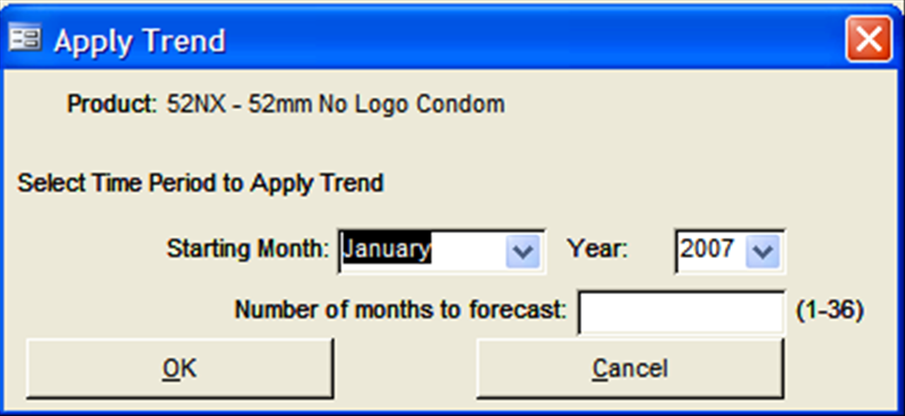
Figure 1—Apply Trend window
The first month and year for which no actual data are entered will be displayed as the starting month and year. You can change these parameters if you wish to add data further into the future, but existing actual consumption will not be overwritten. A trend line forecast may be entered for time periods already past.
The number of months to forecast can be any number up to 36, a three-year period. Enter the number of desired months of forecast data.

- Click OK to apply the trend analysis.

If you are applying the trend to a past time period, a warning message appears:
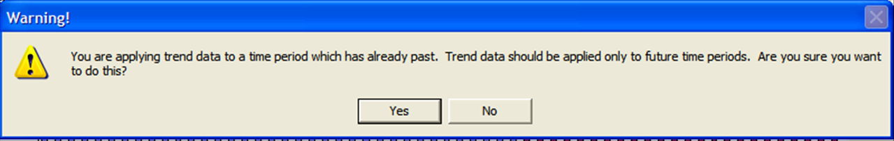
Figure 2—Past Time Period Warning Message

PipeLine verifies the extrapolation method and time period before applying the trend analysis.
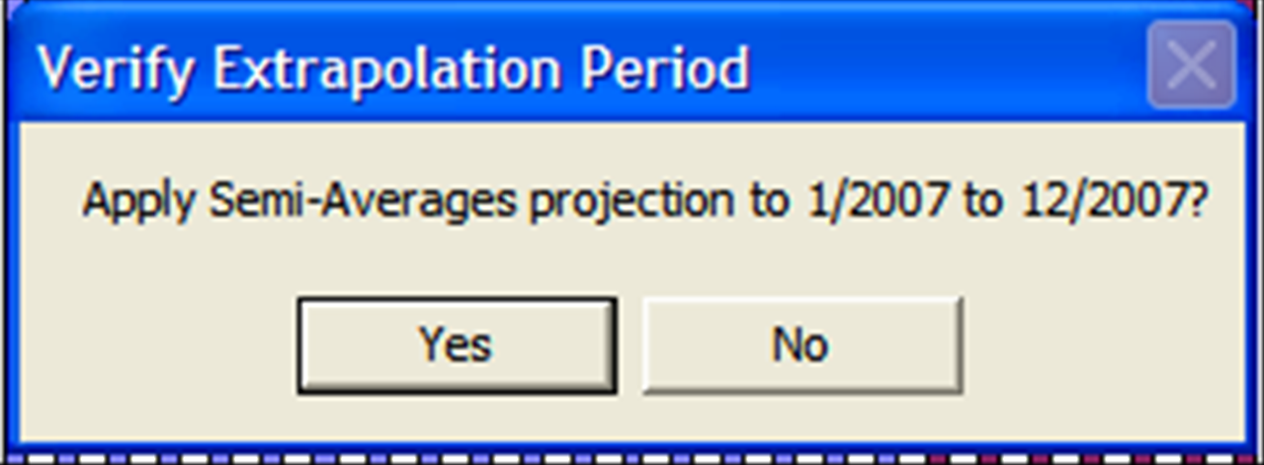
Figure 3—Verifying the Extrapolation Period
- Click Yes to continue applying the trend analysis or No to cancel the operation and return to the Trend Analysis Graph screen.

If a forecast exists for the selected time period, PipeLine will verify that you want to overwrite the existing forecast.

- Click Yes to overwrite the existing forecast.
Click No only to overwrite any portion of the time period for which no forecast exists.
Click Cancel to cancel the Apply Trend operation and return to the Trend Analysis Graph screen.

A message confirms the number of new records added (for time periods with no data input) and the number of records replaced (for time periods with existing data overwritten).
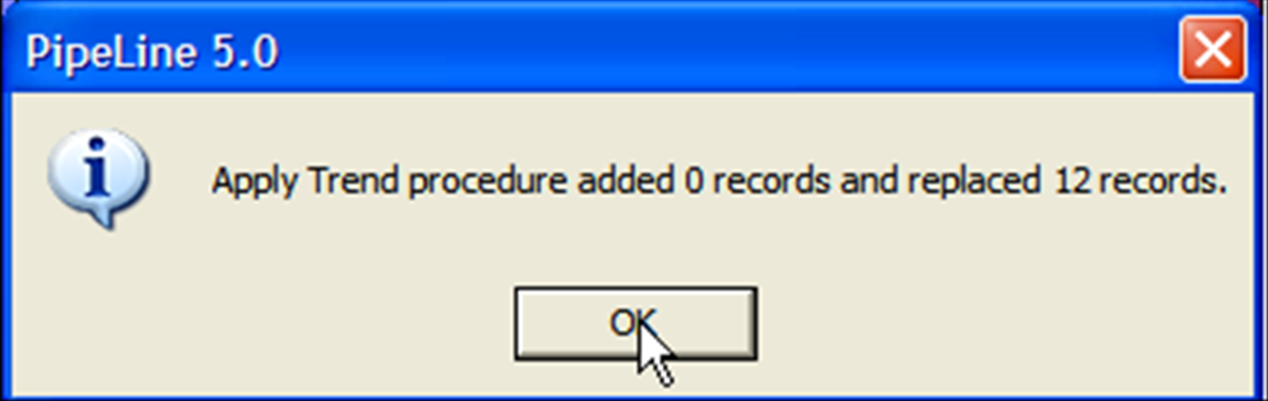
Figure 4 – Apply Trend Confirmation Message
!! | Consumption generated by a trend analysis is always marked as forecast. Trend data are entered monthly; the data source of applied trend data is automatically entered as projected trend.

Continuing Known Issues in PipeLine 5.1
The following issues continue to occur in PipeLine 5.1, but fixes and workarounds for these exist. These issues and ways to resolve them are described below.

Inability to import or export XML files
PipeLine 5.1 can import and export files in extensible markup language (XML) format. These files may be:
- product lists from the USAID | DELIVER PROJECT or Supply Chain Management System project
- forecasts from Quantimed
- consumption data from Supply Chain Manager
- shipment changes from other PipeLine databases

If you experience difficulty importing and exporting XML files, update your computer with Microsoft XML Core Services 6.0 (MSXML 6.0), which is included in the PipeLine installation CD (Figure 5) and the PipeLine web-based installer. Installing MSXML 6.0 should resolve difficulty importing and exporting XML files.
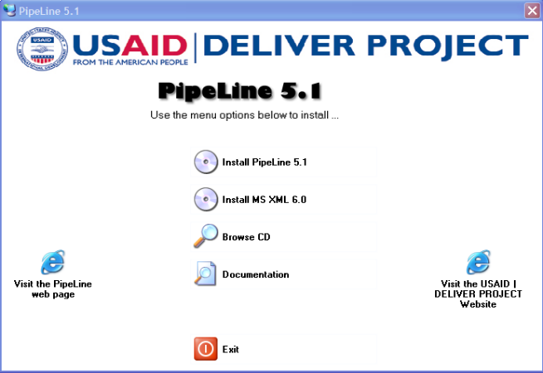
Figure 5 – CD installation screen, including MSXML 6.0

When to update your computer to MSXML 6.0

Even if you have MSXML 6.0 installed, during installation of PipeLine 5.1, you may receive the following message:
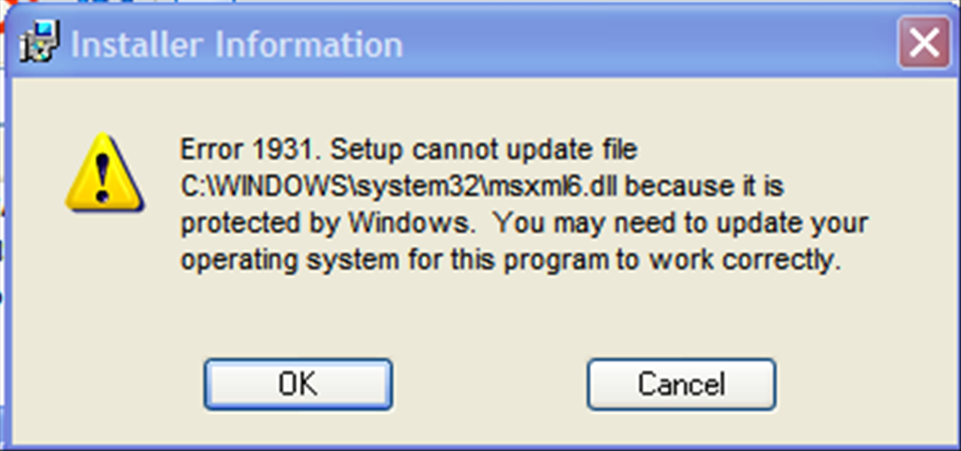
Figure 6 – Protected File Error Message
This message simply indicates that the computer’s system files are protected and cannot be updated by programs other than Windows. It does not indicate a problem using the xml import and export features in PipeLine.

If you receive this message during installation:
- Allow the installation to finish.
- Open PipeLine and attempt an xml import or export.
- If the import or export works correctly, do nothing further. Your machine is up-to-date.
If the message refers to a version predating MSXML 6.0 (version 4.0, for example) or if an attempt to import or export xml fails, you must update your computer with MSXML 6.0.
To update your computer:
- Close PipeLine.
- Return to your PipeLine installation CD and install MSXML 6.0 on your machine.
If you are prompted to reboot your machine during installation, allow the reboot to occur and continue with installation.
- Reopen PipeLine and attempt the xml import or export again.
Installing MSXML 6.0 should resolve the problem.

Graphs Do Not Refresh
If you are using a newer version of Microsoft Office (2007 or 2010) or running a newer operating system such as Windows Vista or Windows 7, you may not automatically see graphs on-screen in PipeLine after changing screens or parameters. This is caused by changes between Microsoft Office 2003 and Microsoft’s Windows XP operating system, and newer versions of Office and Windows. As of this writing, there is no fix for this issue, but clicking the “Preview” button will display the graphs.
If graphs do not appear:
- On the graph screen, click the Preview button.
- The graph will appear in the Preview window in printable report form.
- Print the graph in report form or return to the main graph screen.
The graph will subsequently appear after you close the print preview and return to the graph screen in PipeLine.

Export to MS Excel Does Not Work
If your computer is running Microsoft Windows 7 and Microsoft Office 2007, you may experience difficulties exporting reports into Microsoft Excel. This is caused by changes between Microsoft Office 2003 and Office 2007. To restore the ability to export to Excel, install Microsoft Office 2003 Service Pack 3 (SP3), which is included on the PipeLine installation CD. Installing SP3 will not cause newer versions of Microsoft Office to revert to 2003. It will install a component of Microsoft Access runtime needed for the export to Excel to work properly.
If you are running Microsoft Office 2007 in French, Portuguese or Spanish, you should install the Service Pack in the appropriate language for your computer. These service packs are also included on the PipeLine installation CD.

